Order form for a new book:
Curtain Wall Engineering
(About Designs, Inspections and Calculations for Curtain Walls, Aluminum Windows, Glass Walls, Louvers, Skylights, Metal Claddings, Canopies and Balustrades)
By Dr. Wilson Y S ZHOU ISBN 962-86637-1-2
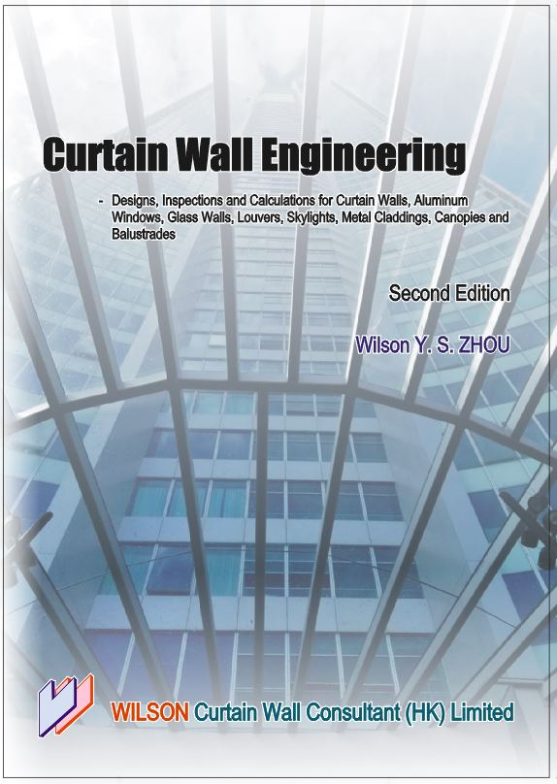
Name: Mr/Mrs/Miss/Dr/Jr ____________________________________
(Full name in block letters, Surname first)

Position in the organization:
__________________________________________________________

Organization:
__________________________________________________________

Address:
__________________________________________________________

__________________________________________________________

Tel: _________________ Fax: ________________ Email: _________________________________

To place your order, please mail this form completed together with a check payable to
“Wilson Curtain Wall Consultant (HK) Limited” to

Dr. Wilson ZHOU
Wilson Curtain Wall Consultant (HK) Limited
Room 1514, 15/F., Technology Park, 18 On Lai Street,
Shatin, New Territories, Hong Kong
Tel: (852) 2645 1802 Fax: (852) 2645 1824
Website: www.curtainwall.com.hk
E-mail: wilson@curtainwall.com.hk

Please tick all the boxes that apply:
□ Yes I want to buy ___ copy(ies) of the book and a check is enclosed.
□ No, I do not want to buy the book.

□ HK$750 per copy; (US$100 / Per copy + delivery)
□ Payment for 5 copies or more (a 10% discount is allowed).
□ No delivery charge if inside Hong Kong.
□ Delivery to USA or Canada or Europe or UK or Australia or Japan is US$35 through air mail
□ Delivery to USA or Canada or Europe or UK or Australia or Japan is US$14 through surface mail

